Decision Log 3 (Updated)
API-Based Querying for StackEval Execution and First Prototype Validation
Project | StackEval Benchmark – Professional Research Project | Document type | Decision Log
Prepared for | Portfolio evidence / GenAI project documentation | Date | 31 March 2026
Updated from | Original Decision Log 3 + prototype validation work | Prepared by | Kenan

At a glance
Final decision: Use API-based querying instead of manual prompting for benchmark execution. | LO stages: Analyzing, Advising, Designing, Realizing, Managing

Research question
Which querying method is more suitable for executing the StackEval benchmark project: API-based querying or manual prompting?
0. Context – Why does this question exist?
After selecting the project focus and the benchmark model set, the next critical step was deciding how the models would actually be queried during the experiment. This decision matters because the StackEval recreation depends on fair comparison: the same real programming question must reach each model in a controlled way before developers can score the answers.
If I continued with manual prompting, the benchmark would remain vulnerable to human error during copying, pasting, formatting, and saving outputs. That would weaken the reliability of the dataset and the validity of later developer scoring. In contrast, an API-based workflow can send one question to multiple models, collect the outputs automatically, and save them in a structured format for later evaluation.
This updated log sits between earlier project choices and the full benchmark execution stage. It builds directly on my project-selection log, my model-selection decision, and my original API-vs-manual comparison. It also incorporates the first working prototype validation, turning the decision from a design choice into an evidence-based implementation result.
1. Current LO stage
☑ Analyzing ☑ Advising ☑ Designing ☑ Realizing ☑ Managing
2. What makes a good decision here?
My criteria for success:
• The method must return responses from all selected models in under 1 minute per question.
• The method must have a low risk of human error during data collection.
• The method must be reproducible and scalable for multiple benchmark questions.
• The method should have professional relevance.
3. What I decided
I decided to use API-based querying to interact with LLM models in the StackEval benchmark instead of manual prompting.
4. Why this decision
Method I used
I used a combination of benchmark analysis, comparative research, provider/platform review, and implementation testing.
• I reviewed the original StackEval project and benchmark paper to understand how a structured coding benchmark is executed and why reproducibility matters.
• I created a comparison between API-based querying and manual prompting to evaluate the two methods against the needs of this project.
• I checked the selected model providers and platforms to confirm whether my chosen models were actually accessible through API workflows.
• I then implemented and tested an API-based setup in practice, including provider connection, debugging, and output saving.
What I found
• Manual prompting is simple to start, but it introduces inconsistency, repetitive manual work, and a higher risk of copying or saving mistakes.
• API-based querying supports identical inputs across models, automatic output collection, and a cleaner path from one test question to a full benchmark dataset.
• The selected providers were practically usable for this benchmark setup: OpenAI and Anthropic via their official APIs, and Llama 4 Maverick through OpenRouter as an API access layer.
• The API workflow worked in practice after setup and debugging, which confirmed that the decision was not only theoretically better, but also executable within the project.
Evidence and artifacts
Artifact / source | Why it matters | Status in portfolio
Original StackEval GitHub repository and paper | Supports the benchmark methodology and shows that structured evaluation pipelines are central to the original approach. | External source
API vs. Manual comparison document | Documents the comparative reasoning that led to the decision before implementation began. | Research evidence
Official provider/platform pages | Confirm API availability and model access routes for OpenAI, Anthropic, and OpenRouter. | External source
Working Python scripts + saved outputs | Show that the setup was implemented, tested, and able to save benchmark-ready results. | Implementation evidence
API Setup Progress and Evidence Log | Records the step-by-step implementation trail, encountered issues, and fixes. | Supporting evidence
Note: the progress log remains a separate evidence document. Its implementation trail supports this decision log rather than replacing it.
What this means
This means API-based querying is the more suitable method for this project because it protects the fairness of model comparison, reduces manual handling, and creates a reproducible path from a single test question to a larger benchmark dataset.
So I decided to continue the StackEval recreation with an API-based workflow, supported by automated querying, structured output saving, and evidence from live implementation testing.
Implementation snapshot
The first working prototype already demonstrates practical time efficiency: one run can collect outputs from the selected models within roughly 30–35 seconds, which stays comfortably below the project criterion of 1 minute per question.
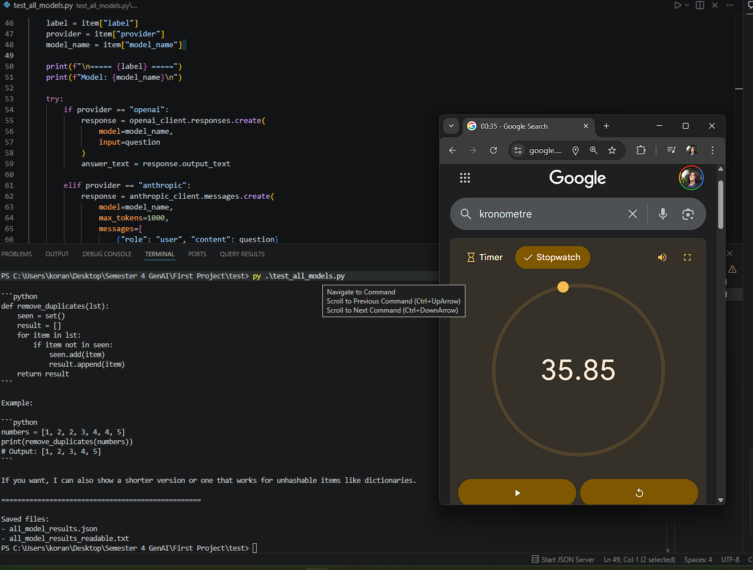
Figure 1. Example runtime observation from the combined script (≈34.8 seconds).
5. Does this hold up?
Criterion | Result | Notes
Under 1 minute per question | Yes | Observed runtime for the combined script was approximately 30–35 seconds.
Low human-error risk | Yes | One question can be entered once and saved automatically, avoiding repeated copying and manual storage.
Reproducible and scalable | Yes | The same script can be reused for a larger set of real programming questions with consistent input handling.
Professional relevance | Yes | The workflow mirrors real API integration, automation, and operational debugging work.
Assumptions
• API services will remain accessible during the later benchmark phase.
• Costs will remain manageable within the scope of a student project.
• The same pipeline can be extended from a small prototype to a larger question set without requiring major redesign.
What surprised me
• API-based querying was easier to implement than I first expected.
• The biggest blockers were operational issues such as billing, package setup, and environment configuration rather than the API call logic itself.
• Readable output files became more important than expected, because developers will need a clean file to score rather than raw technical output.
Managing reflection
This log also contains an early but real Managing component. I did not only build the setup; I monitored where it failed, identified causes, and improved the pipeline step by step. Examples include solving package installation issues, correcting environment variable naming, resolving billing access, and improving output formats from terminal-only responses to JSON plus readable TXT. In this project, Managing is therefore not limited to model quality; it also includes keeping the whole benchmark pipeline usable and reliable.
6. What this unlocks
• I can now generate responses for a larger benchmark set automatically instead of collecting every answer manually.
• I can quickly build a structured dataset of model outputs for later human scoring.
• I can start collecting real programming questions and decide the final benchmark size (likely around 30–50 questions) based on time and scoring feasibility.
• I can hand developers ready-to-use evaluation files instead of asking them to work from messy copied outputs.
Implementation evidence
Working multi-model scripts, saved JSON and TXT outputs, runtime observation screenshot, and the separate API Setup Progress and Evidence Log can all be attached as portfolio evidence for this decision.
Next LO stage
Realizing → Managing
What I can now do
Run multiple real programming questions through all selected models, collect and save the outputs systematically, determine the final number of benchmark questions, and prepare the material for developer scoring.
How I will know this worked
If I can generate a full benchmark dataset from the selected questions and developers can directly evaluate the saved files without needing additional data preparation, then this decision has worked as intended.
7. Key sources and platforms used
Source | Why it was used | Link
ProsusAI / stack-eval (GitHub) | To study the benchmark structure and align the recreation with the original project approach. | Open link
StackEval paper (OpenReview) | To support the benchmark rationale and the use of real developer questions. | Open link
OpenAI documentation | To verify current model availability and the recommended API direction for GPT-5.4 and GPT-5.4-mini. | Open link
Anthropic documentation + Sonnet 4.6 announcement | To verify Claude API model availability and current naming/versioning. | Open link
OpenRouter Llama 4 Maverick page | To document the API access route used for the open-model category. | Open link
Meta Llama 4 announcement | To support the model-family description behind Maverick. | Open link
Related internal project documents
• Portfolio Guide
• Decision Log Documentation for the GenAI Project
• GenAI Project Learning Outcomes Guide
• StackEval Project Understanding Document
• Decision Log 2 – Updated (model selection)
• API Setup Progress and Evidence Log
This document merges the methodological decision from the original API-vs-manual log with the first prototype validation work, so that the decision is supported by both research reasoning and implementation evidence.

